Innovative Solutions Application Report

Table of Contents

Introduction 1

Requirements 1

Functional Requirements 1

Non-Functional Requirements 1

Working Hypotheses 1

Specification 2

Actors and Use Cases Diagram 2

Application Dataflow 3

Software Architecture 4

Object-Oriented Application Design 5

Classes Diagram 5

Classes Definitions 6

Classes Attributes 6

Classes POJO Implementations 8

POJO classes derivation into persistence entities 10

Entities Relationships Implementation 13

Persistence Entities Implementation (final) 15

persistence.xml 16

JPA-generated Database 17

Complete Application UML Diagram 17

Introduction

The following paper illustrates the design steps and the choices made for the development of an application based on a relational database devised to meet the data management requirements of a fictional tech company named *Innovative Solution*.  
  
The first part of the paper covers the application’s functional and non-functional requirements from which the application’s specifications are derived, consisting among other things of the actors involved and their use cases, the application dataflow, and an overall description of the software architecture.  
  
The second part of the paper presents the object-oriented design of the software solution, where the classes relevant for the application and their relationships are defined, along with how such classes can be derived into *persistence entities* in order to persist the data of our application in an underlying MySQL database through the JPA.

The third and final part of the paper covers the details on the implementation of the key-value database management module…

Requirements

*Innovative Solutions* is a company whose core business consists in the retailing of electronic IoT-oriented products assembled in-house by teams of employees from components purchased from various suppliers.

Functional Requirements

The company requires a software solution which should be used by its system administrator to oversee and control all the information concerning the company, by its team leaders, who should be able to add finished products to the company stock and review information on its team members, and by the company’s customers, who will be allowed to purchase the products and review their orders.

Non-Functional Requirements

Since the application should not require computer expertise to be used, especially by customers, to enhance the non-functional requirement of usability a graphical interface should be provided for the application.

In addition, due to the company’s system administrator strong background in object-oriented programming, the application should be developed attuning to an object-oriented paradigm, concealing as much as possible the data persistence aspects.

Working Hypotheses

The design of the application will also rely on the following working hypotheses:

* *Customers* may purchase any *Products* up to their available quantities
* Each *Employee* in the company may belong to up to one *Team*
* Each *Team* is composed of at least one member, representing its leader
* Each type of *Product* offered by the company is assembled by a single team

Specification

Actors and Use Cases Diagram

Given the software functional requirements, the application is meant to be used by three different actors, each being allowed to perform a different set of operations:

* The company’s system administrator, who is permitted to perform a number of actions requiring a high level of privilege, such as inserting or removing a customer or an employee from the database or updating the salary of an employee.
* The team leaders, who are allowed to add finished products to the company stock and review information on the member assigned to their team.
* The customers, who may view and purchase the products on offer, as well as review their past orders.

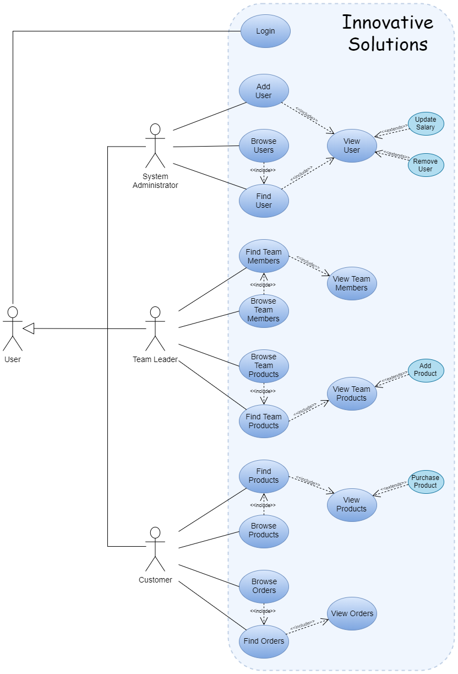

Application Dataflow

The projected dataflow of the application is outlined below:

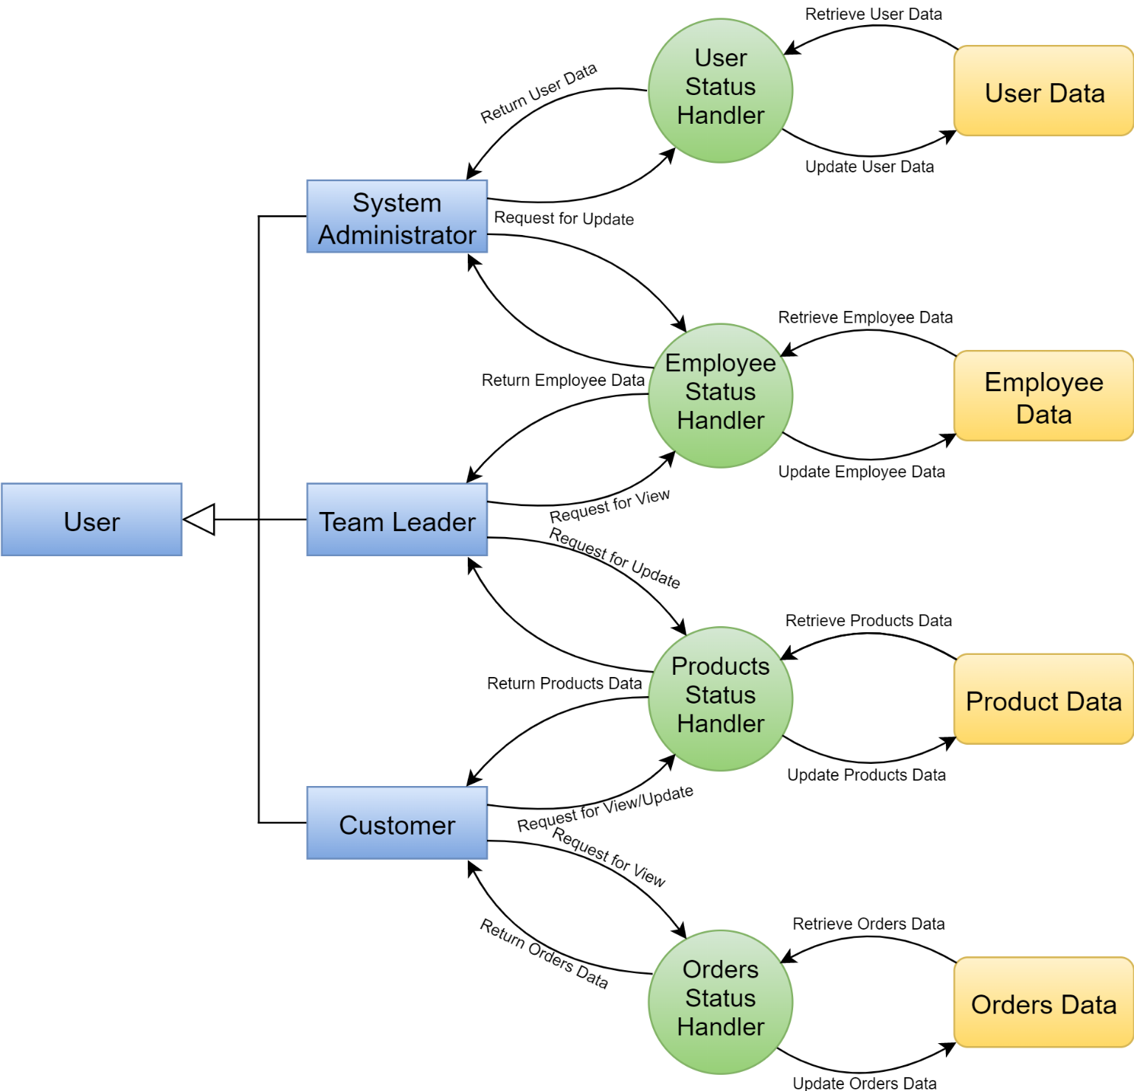

Software Architecture

The application will be written in the *Java* programming language, where the graphical interface will be developed through the JavaFX API, while the data persistence aspects of the application will be handled by the *Hibernate* framework implementation of the Java Persistence API, which by performing an Object-Relational Mapping (ORM) will transparently exchange the data between the application and an underlying MySQL database.  
  
More precisely, the software architecture can be divided into the following tiers:

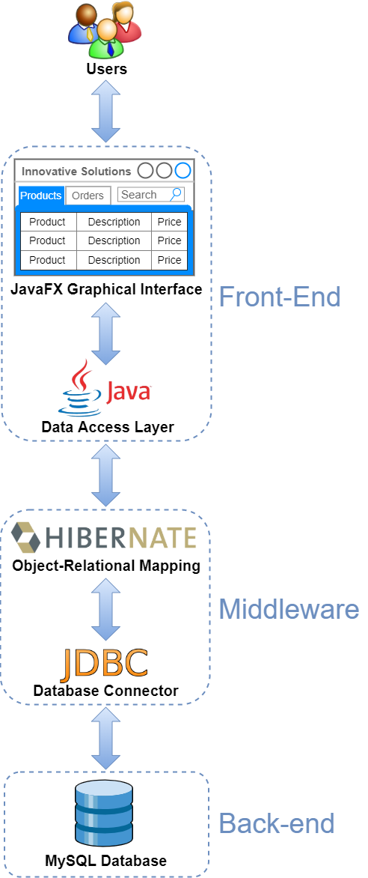

Object-Oriented Application Design

Analysis Classes Diagram

From the application’s requirements and the additional working hypotheses the following classes can be identified as the first step in the application’s design:

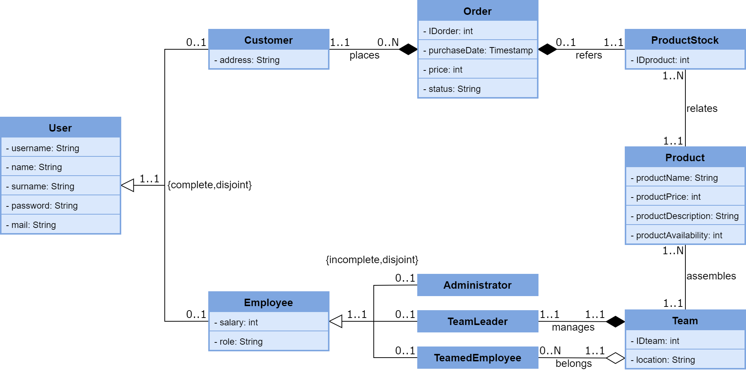

Classes Definitions

|  |  |
| --- | --- |
| CLASS | DESCRIPTION |
| User | An individual of interest in the context of the application, who may be a customer or an employee of the company |
| Customer | A customer of the company, who may purchase products and review their orders |
| Employee | An employee of the company who, other than a generic employee, can represent its system administrator, a team leader, or a team member |
| Administrator | The company’s system administrator |
| TeamLeader | The leader of a team of employees |
| TeamedEmployee | A member of a team of employees |
| Team | A team in the company, which is composed of a team leader and other members, where each team is assigned the assembly of one or more products |
| Product | A specific category of product offered by the company, which can be purchased by customers |
| ProductStock | A physical instance of a product sold by the company, which is related to a specific product category and is sold to customers |
| Order | An order placed by a customer, which is relative to a physical instance of a product sold by the company |

Classes Attributes

|  |  |  |
| --- | --- | --- |
| User | | |
| **Attribute** | **Type** | **Description** |
| username | String | A unique string identifying a user, which is also used by them to access the application |
| surname | String | The user’s name |
| surname | String | The user’s surname |
| password | String | The password required for the user to access the application |
| mail | String | The user’s e-mail address |

|  |  |  |
| --- | --- | --- |
| Customer | | |
| **Attribute** | **Type** | **Description** |
| address | String | The customer’s address, which is used for product shipping purposes |

|  |  |  |
| --- | --- | --- |
| Employee | | |
| **Attribute** | **Type** | **Description** |
| salary | int | The employee’s salary |
| role | String | The employee’s role in the company |

|  |  |  |
| --- | --- | --- |
| Administrator | | |
| **Attribute** | **Type** | **Description** |
| none (same as the superclass) | | |

|  |  |  |
| --- | --- | --- |
| TeamLeader | | |
| **Attribute** | **Type** | **Description** |
| none (same as the superclass) | | |

|  |  |  |
| --- | --- | --- |
| TeamLeader | | |
| **Attribute** | **Type** | **Description** |
| none (same as the superclass) | | |

|  |  |  |
| --- | --- | --- |
| Team | | |
| **Attribute** | **Type** | **Description** |
| IDteam | int | The team’s unique identifier |
| location | String | The team’s working location |

|  |  |  |
| --- | --- | --- |
| Product | | |
| **Attribute** | **Type** | **Description** |
| productName | String | The product’s name |
| productPrice | int | The product’s current asking price |
| productDescription | String | A brief description of the product |
| productAvailability | int | The product’s current stock availability |

|  |  |  |
| --- | --- | --- |
| ProductStock | | |
| **Attribute** | **Type** | **Description** |
| IDstock | int | The unique identifier of an instance of a product category |

|  |  |  |
| --- | --- | --- |
| Order | | |
| **Attribute** | **Type** | **Description** |
| IDorder | int | The order’s unique identifier |
| purchaseDate | Timestamp | The date and time the order was placed |
| price | int | The price of the product relative to the order |
| status | String | The status of the order’s shipment (received, shipping, delivered) |

Classes POJO Implementations

The following represent the POJO implementations of the classes of our application:

User.java



Customer.java



Employee.java



Administrator.java



TeamLeader.java



TeamedEmployee.java



Team.java



Product.java



ProductStock.java



Order.java



POJO classes derivation into persistence entities

As the next step in the application’s development, the POJO classes previously defined must be derived into *persistence entities,* which is obtained by complementing their definitions with the appropriate JPA annotations.  
It should also be noted that regarding the inheritance we have opted, as a design choice, to map the User superclass and all its subclasses (Customer, Employee, Administrator, TeamLeader, TeamedEmployee) into a single table in the database, a solution which provides the best performance in terms of number of accesses required to retrieve the state of an entity, at the cost of a higher memory footprint, given that the attributes specific to each subclass are repeated as fields in all other subclasses.

User.java



Customer.java



Employee.java



Administrator.java



TeamLeader.java



TeamedEmployee.java



Team.java



Product.java



ProductStock.java



Order.java



Entities Relationships Implementation

Next we present our design choices regarding the implementation of the relationships between the persistence entities:

* TeamLeader ⇌ Team (One to One)  
  This relationship is implemented as a OneToOne unidirectional relationship between the *TeamLeader* and *Team* entities, which is obtained by adding to the former an “IDteam” attribute identifying the Team managed by the TeamLeader.  
  The relationship is implemented as unidirectional since from the application’s specification, and more precisely from its use cases, it is required to retrieve the Team managed by a TeamLeader, but not vice versa.  
    
  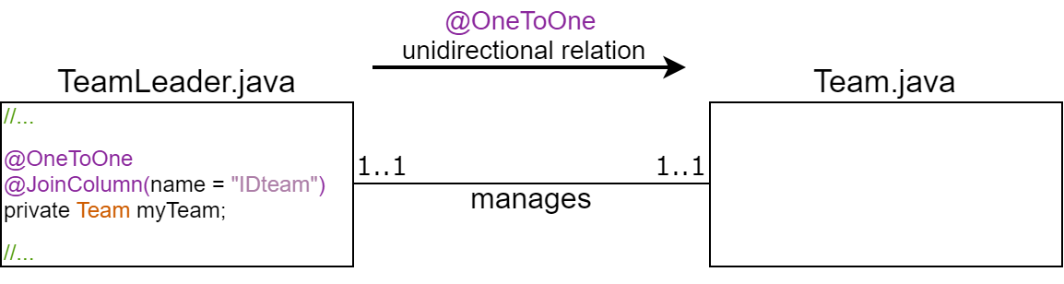
* Team ⇌ TeamedEmployee (One to Many)  
  This relationship is implemented as a OneToMany bidirectional relationship between the *Team* and *TeamedEmployee* entities, which is obtained by adding to the former a “members” attribute identifying the list of TeamedEmployees that belong to the Team and by adding to the latter an “IDTeam” attribute identifying the Team the TeamedEmployee belongs to.  
  The relationship is implemented as bidirectional since in our application it is necessary to retrieve both the list of TeamedEmployees belonging to a Team and the Team a TeamedEmployee belongs to.

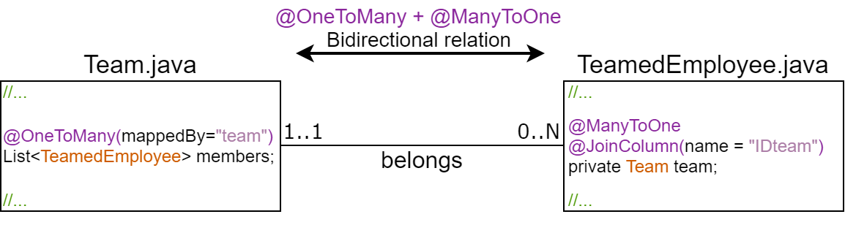

* Team ⇌ Product (One to Many)  
  This relationship is implemented as a OneToMany bidirectional relationship between the *Team* and *Product* entities, which is obtained by adding to the former a “teamProducts” attribute identifying the list of Products assembled by the Team and by adding to the latter an “IDTeam” attribute identifying the Team in charge of its assembly.  
  The relationship is implemented as bidirectional since in our application it is necessary to retrieve both the list of products assembled by a Team and which Team is in charge of the assembly of a Product.   
    
  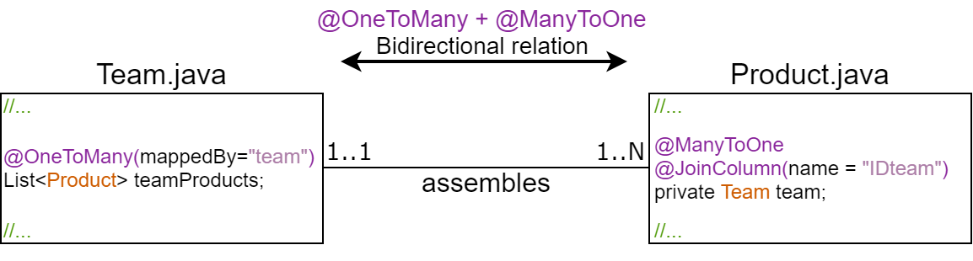
* Product ⇌ ProductStock (One to Many)  
  This relationship is implemented as a ManyToOne unidirectional relationship between the *ProductStock* and *Product* entities, which is obtained by adding to the former a “product” attribute identifying the category the physical product belongs to.   
  The relationship is implemented as unidirectional since from the application’s specification it is required to retrieve the category a physical product belongs to, but not vice versa.  
    
  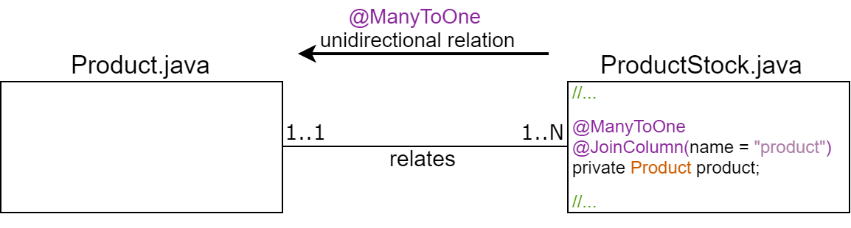
* Order ⇌ ProductStock (One to One)  
  This relationship is implemented as a OneToOne unidirectional relationship between the *Order* and *Product* entities, which is obtained by adding to the former a “productStock” attribute identifying the IDstock of the physical product related to the Order.   
  The relationship is implemented as unidirectional since from the application’s specification it is required to retrieve the physical product relative to an Order, but not vice versa.  
    
  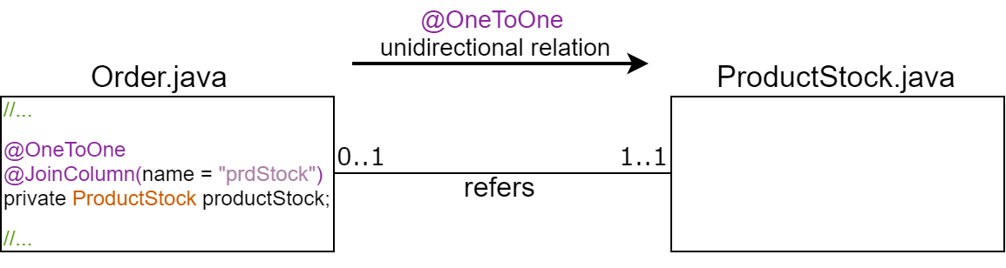
* Customer ⇌ Order (One to Many)  
  This relationship is implemented as a OneToMany bidirectional relationship between the *Customer* and *Order* entities, which is obtained by adding to the former a “myOrders” attribute identifying the list of Orders relative to the Customer and by adding to the latter a “customer” attribute identifying the Customer the order refers to.  
  The relationship is implemented as bidirectional since in our application it is necessary to retrieve both the list of Orders relative to a Customer and which Customer is relative to an Order.   
    
  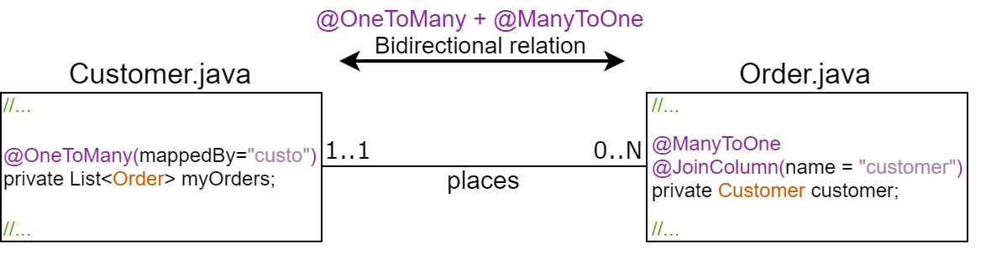

Persistence Entities Implementation (final)

The final implementation of the persistence entities complete with their methods required by the application logic can be found in the attached project grouped under the “DataManagment.Hibernate” package, where each class has been prefixed with an “H” character to prevent naming collisions with other classes in the application:

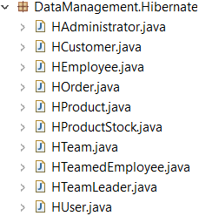

persistence.xml

Here follows the *persistence.xml* configuration file for the JPA used in our application:



JPA-generated Database

The MySQL database generated by JPA from the persistence entities we have defined is shown below:

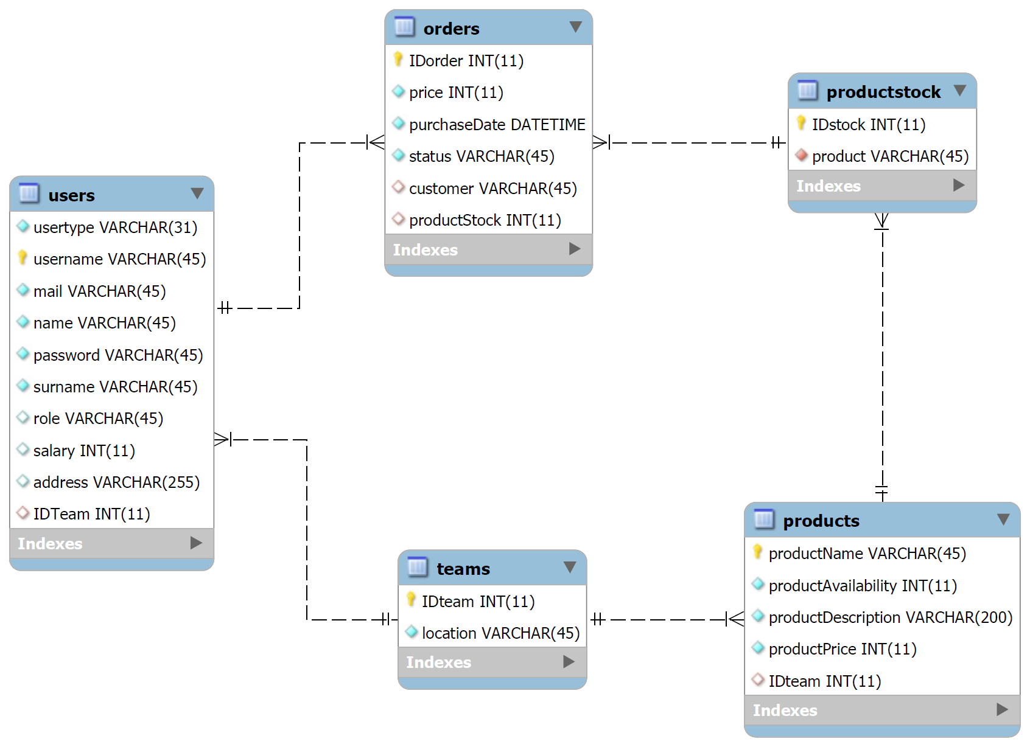

Complete Application UML Diagram

The complete UML diagram of the devised application is shown below: